**4COSCO11C.2 Web Design and Development**

**Tutorial 6**

### Task 1 - Create your Web Page content

#### Open your tutorial5.html and save it as tutorial6.html.

#### **HTML**

Your Web Pages should follow the following specifications.

* Update the title to Tutorial 6
* Update the last modified date (just as hard coded date)

### Task 2 - Update the code to use Arrays and Functions

#### **JavaScript**



* Declare an array to hold the user numbers (userNumbers) and an array to hold the lottery numbers (lotteryNumbers).
* Declare and write a function called enterUserNumbers() to store the user numbers. This function will
  + prompt the user for their 6 chosen numbers, one at a time, as you did in the Tutorial 5 extension. Remember that you will need to turn the input into an integer. You will also need to make sure they do not give the same number more than once (you can use the includes method for this), and that the numbers must be between 1 and 59. You can also use the push() method to add the number to the array of numbers.
  + Display the number numbers in the placeholders you prepared in the HTML section. You should use the innerHTML() method for this. You will just need to modify your code from tutorial 5 to do this in a for loop. See the Lecture Video for Arrays and Methods for how to construct the string from "displayUserNum" and concatenate it with a number constructed partially from the loop index to get a string that matches the placeholder id
* Declare and write a function called drawLotteryNumbers() that randomly generates 7 numbers between 1 and 59 and stores them (using the push() method) to the lotteryNumbers array. You will need to just modify your code from Tutorial 5 for this. Each number must be unique so each time you draw a new number, you must check that it isn't already in the array, or you will need to draw a new one again.
* Declare and write a function called displayLotteryDraw() that displays the lottery numbers from the lotteryNumbers array in the "draw" div. You can again use the innerHTML() method. Remeber to add the class highlightBonus to the seventh number which represents the Bonus number.
* Declare and write a function called checkWin() that compares each of your user numbers to each of the lottery numbers. If there is a match, add the class "highlightWin" if it matches the main numbers, and the class "highlightBonusWin" if it matches the bonus number. I recommend to check the bonus number first and to then remove this number from the lotteryNumbers array using the pop() method before checking the user numbers for a win against the lottery main numbers
* Call all these functions in the correct order to run one game and one draw.

### ask 3 - Check your work

• Remember, you can check if your markup is syntactically valid using the Validator at: <https://validator.w3.org/>

* Use the ‘Validate by File Upload’ or ‘Validate by Direct Input’.

Tutorial Extensions

* Modify your code to allow to generate a number of draws. This time, we will highlight the numbers from the draw instead or the user numbers, see screenshot below:

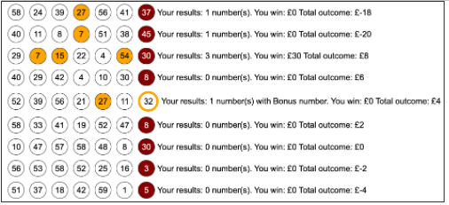

Consider that a draw cost £2, and that the wins are as follows:

* 0 or 1 match on the main numbers, no win
* 2 numbers match the main numbers, you win £2
* 3 numbers match the main numbers, you win £30
* 4 numbers match the main numbers, you win £140
* 5 numbers match the main numbers, you win £1750
* 5 numbers match the main numbers plus a match of the Bonus number, you win £1,000,000
* 6 numbers match the main numbers, you win £2,000,000

You can use the following code for this:

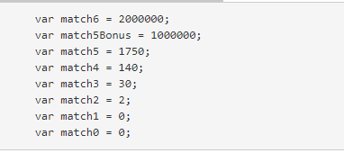

* alongside each draw, specify the details of the draw regarding matched numbers, how much the user has won on this particular draw, and how much they have won altogether. (You can try to run this for 50 draws, and 1000 draws. I don't recommend running this for much more than this as it may crash your browser. Alternatively, you could just run with no display for a larger numbers of draws).  
  Note that you can construct a string that corresponds to the match (e.g. match4) and evaluate that string using the eval() function to get the corresponding win. See the Lecture video on array and functions for that example.

Task 2 - Complete the Tutorial 6 Test on Blackboard

* Go to Assessment -> Tutorial Tests -> Tutorial 6 Test and complete the test. You can have up to five attempts to get the maximum score of 3 marks